**RESUME**

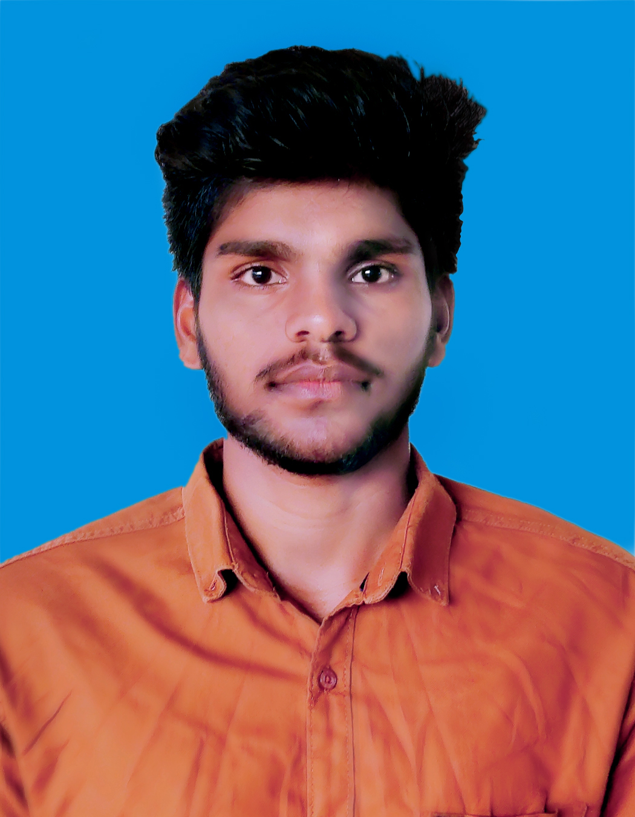

**RAVI KUMAR P**

**Address :** ChandravanamEstate**,**Vandiperiyar

Idukki(Dt),Kerala

Pin:685533

**Mobile :** +91-8086861395

**E-Mail :** [pravikumar014@gmail.com](mailto:palaniraj169@gmail.com)

**CAREER OBJECTIVE**

Looking for a challenging career which demands the best of my professional ability in terms of technical and analytical skills and helps me in enhancing my current skill and knowledge.

**ACADEMIC QUALIFICATION**

**B.E Anna University, Chennai (2016-2020)**

Computer Science Engineering

MET Engineering College, Aralvaimozhi.

**HSC From Govt hr sec school (2015-2016) 68.5%**

Rajankam Govt Kallar Higher Secondary School, Gudalur.

**SSLC Tamil Nadu State Board (2013-2014) 73%**

CPU Higher Secondary School, Cumbum.

**AREA OF INTEREST**

* + Software Engineer
  + Network Admin
  + Hardware Engineer

**SKILLS**

* Team worker
* Willingness to learn.

**CO CURRICULAR ACTIVITIES**

* Participated in one-day workshop on **“HARDWARE AND NETWORK"** in my college.
* Participated in one-day workshop **“CODING TECHNOLOGIES - ANGULAR JS(.net)"** atGIFT WEB SOLUTIONS, Nagercoil.

**ACHIEVEMENTS**

* I have attend Internship in "**ADVANCE .NET TECHNOLOGY"** for one month at

CENTAURUSS.

**COMPUTER SKILLS**

* **C**
* **C++**
* **Java**

**PERSONAL DETAILS**

**Father’s Name :** Mr.Pandiyan

**Mother’s Name :** Mrs.Lakshmi P

**Gender :** Male

**Date of Birth :** 30-05-1999

**Nationality :** Indian

**Known Languages:**

Tamil - Read, Write, Speak

Malayalam. - Read, Speak

English - Read, Write, Speak

**Hobbies. :** Cricket, Volleyball, Swimming.

**ACADEMIC PROJECT**

* **Collusion** **Defender**
* **Description** : secure information sharing in E - Health services

become using cryptography with key setup.

* **Duration :** 3 months.

.

**DECLARATION**

I hereby declare that all the above said facts are true to the best of my knowledge.

**Date:**

**Place:**  **[RAVI KUMAR**